Managing the risk of harmful plants

Introduction
There are a number of plant varieties in the UK, both native and invasive, which may pose a risk is unmanaged in playing fields, gardens and other outdoor areas.
While these plants do pose a hazard, the risk of serious poisoning by plants, skin reactions and allergies is generally low in the UK.
The purpose of this document is to highlight the potential risks associated with some more common plant varieties in the UK, and assist schools in proportionate management of these risks.
Remember – Health and Safety management in schools should be sensible, and complete removal of risks can have a detrimental impact on the learning environment. Many of the plants listed in this document provide an important role in the ecosystem and risk can be minimised through education and supervision. This is not a list of plants which must be removed from school sites; although some invasive species are strictly controlled by law and may need removal if they are at risk of spreading to adjoining land.
If you are ever unsure about the identity of a plant, contact your grounds maintenance provider or a horticulturalist.

Quick facts
- If it is not a food plant, do not eat it.
- Teach children not to play with or eat growing plants.
- Use gloves when pruning or weeding and keep skin covered.
- Do not leave prunings or uprooted plants in reach of farm animals or pets.
- Check plant labels for toxicity warnings (sometimes stated on label).

Main hazards

Ingestion
Children are at highest risk of accidental ingestion of harmful plants
Some plants may cause digestive upset or discomfort if eaten
A small of number common garden plants are more toxic and could cause severe poisoning

Contact hazard
Contact with plants can cause skin irritation, either through sap on the surface of the plant, or spines which excrete chemicals such as formic acid (e.g. “Stinging” Nettles).
Sap is a fluid that circulates through a plant's vascular system, in a similar way to blood moving through our veins. Phloem sap carries the sugars produced in the leaves by photosynthesis down to roots and other storage organs, as well as carrying minerals and hormones. Xylem sap is watery and transports nutrients absorbed by the roots upwards to the rest of the plant. Some plants leak sap from wounds or pruning cuts, and this is known as bleeding.
Irritant sap may cause a burning sensation and sometimes blistering of the skin; anyone can be affected if exposure is sufficient
Some plants contain chemicals called allergens. These do not affect everyone, but some individuals may acquire sensitivity to them, resulting in an allergic reaction
A very small number of plants have sap which renders the skin excessively sensitive to strong sunlight. Contact with the plant followed by exposure to sunlight results in very severe, localised sunburn with blistering and long-lasting skin discoloration

What to do if there’s a problem

Adults and children
If you think a child or adult has eaten part of a doubtful plant, seek medical advice immediately from a hospital Accident & Emergency department
Take a sample of the plant with you
Do not panic and DO NOT try to make the person sick

Pets
The HTA Guide to Potentially Harmful Plants gives toxicity information for pets, including dogs, cats, rabbits, rodents, tortoises, caged birds, and poultry.
Where a particular pet is mentioned in the HTA Guide this indicates that type of pet has been adversely affected by a plant; it does not mean that other types of pet will not be affected if they eat or rub against the plant.
Seek veterinary advice if you think an animal has eaten a poisonous plant
Take along samples of the plant concerned

Plant and fungi
Fungi are safe to have in the garden as long as they are not eaten. With a couple of exceptions, the effects of accidently eating small amounts are mild. If you need to identify a mushroom, take photos from all angles, from the top, sides and from underneath so the stem (stipe) and gills/pores are visible. It is safe to touch fungi, as long as you wash your hands afterwards.
In cases of suspected poisoning, seek medical assistance at an Accident and Emergency Department, taking a sample of the plant or fungus/mushroom with you.

Plants potentially harmful to people
Below is a list of plants found in the UK which might pose a risk if consumed or improperly handled and may be found growing in gardens, woodlands and on riverbanks. Staff and pupils should not handle these plants, and should be informed of the associated risks. Japanese Knotweed and Giant Hogweed are invasive species, and it is recommended these be removed by a competent professional.
Name | Description / Where it’s found | Toxicity and Symptoms | Picture
Deadly Nightshade  Atropa belladonna | Has purple-green, bell-shaped flowers and un-toothed, oval leaves. The berries start green and ripen to black. Found mainly in the southern half of the UK in woodland, along paths and in scrubby areas. | All parts of the plant are toxic, but the berries are especially poisonous. Consumption causes severe symptoms including sweating, vomiting, breathing difficulties, confusion, hallucinations and potential coma and death. It also has a pupil-widening effect. | 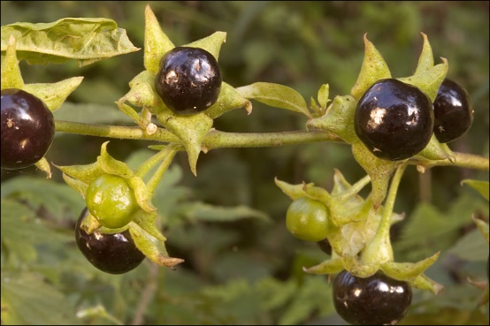  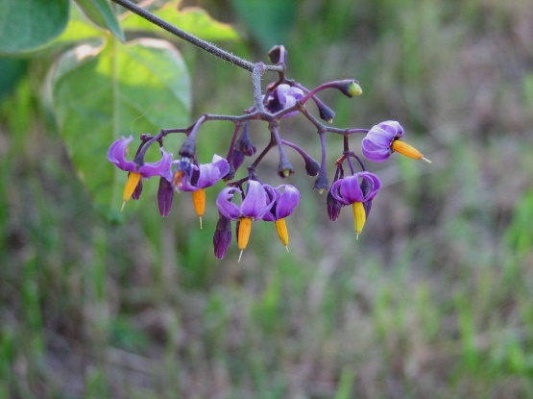
Foxglove  Digitalis purpurea | This common woodland plant is tall and narrow with pink and purple flowers, seen in early summer. It grows throughout the UK, along woodland edges, roadside verges and hedgerows. It's also a common garden plant. It is often misidentified as Comfrey, Symphytum officinale. | Foxglove plants contain toxic cardiac glycosides. Ingestion of any parts of the plant can result in severe poisoning. Symptoms include nausea, headache, skin irritation and diarrhoea. In severe cases it can lead to visual and perceptual disturbances and heart and kidney problems. | 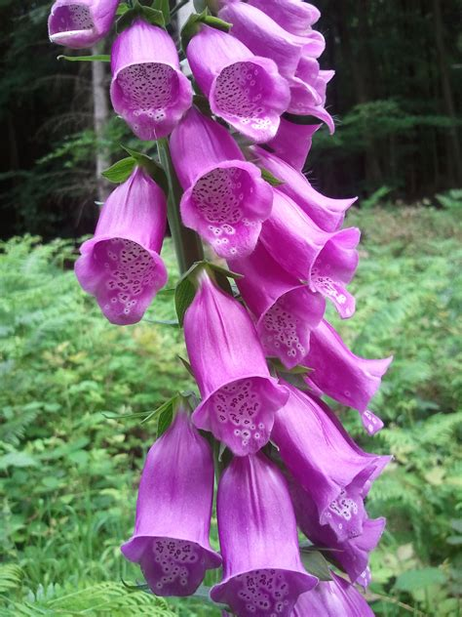
Lords-and-ladies  Arum maculatum | Also known as cuckoo pint, you’ll find this plant in woodland and along hedgerows. It has large, arrow-shaped, purple-spotted leaves at the base of the plant. Its flowering spike has a yellow-green hood surrounding the flower spike (spadix). Its berries are green, orange or red, depending on their ripeness. | Take care when handling this plant. All parts of it can cause allergic reactions, but the berries are particularly poisonous. The plant contains minute needle-shaped crystals which can severely irritate the skin. Consumption can lead to throat swelling, breathing difficulties and stomach irritation.  It’s rare to accidentally eat large quantities of this plant because it has an acrid taste and gives a tingling sensation which acts as a warning. | 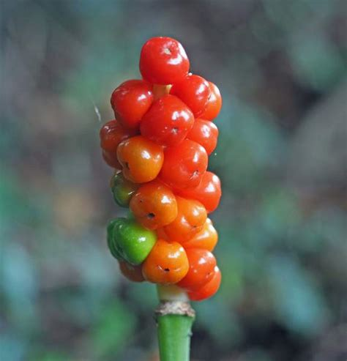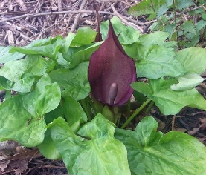
Monkshood  Aconitum napellus | Also known as Adam and Eve or devil’s helmet, this is one of the UK’s most poisonous plants. It’s widely naturalised, but may be native in damp woodlands, meadows and along ditches in the southern half of the UK. Its attractive hooded blue flowers have made it a popular garden plant and you’ll find cultivars in varying colours including pink, yellow and white. Its flowers grow on tall spikes that bloom between June and September. | All parts of the plant are poisonous, particularly the roots. If ingested, it can cause stomach pain and dizziness. The poison also affects the heart and in large amounts can be fatal, but poisonings are rare as it has such an unpleasant flavour. Toxins can even transfer to the skin via cuts, so it is important to always wear gloves when handling plants in your garden. | 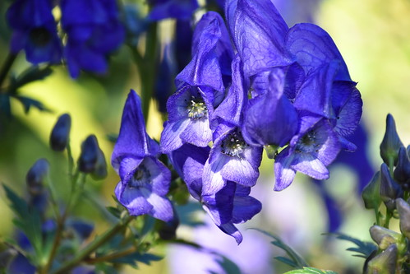
Poison hemlock  Conium maculatum | Poison hemlock is sometimes confused with other species in the Apiaceae family such as cow parsley. It’s a large plant up to 2m tall, with hollow, purple-blotched stems. The mature plants have an unpleasant smell apparently similar to mouse urine. You’ll find it in damp areas along the edges of woodland, along ditches, streams and roadside verges. | It contains several toxic alkaloids including coniine and is poisonous to humans and livestock. Consumption of just a small amount of any part of the plant can cause respiratory paralysis and death. | 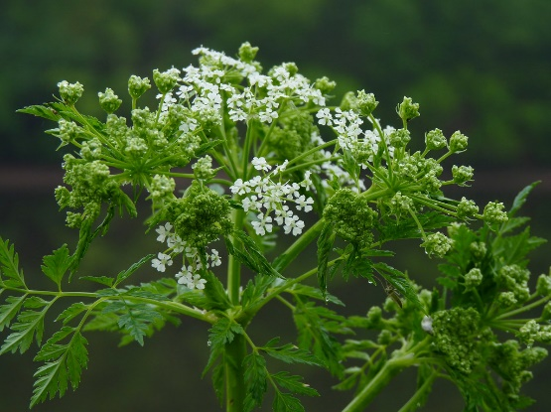
Japanese knotweed  Fallopia japonica | Introduced as an ornamental garden plant by the Victorians. It’s now common in urban areas, especially on wasteland, railways, roadsides and riverbanks. Tough enough to grow through asphalt, it can lead to structural damage. It affects our woods too, by:  outcompeting native species  contributing to river bank erosion and increasing the likelihood of flooding. | Even the smallest fragment of root can grow a new plant so it spreads easily, making it challenging and expensive to manage. In fact, Japanese knotweed is so problematic that it’s a criminal offence to plant it or cause it to grow in the wild.  While not harmful to humans, it is an invasive species which can cause significant damage and ecological harm. If identified it should be reported to the Local Authority or Environment Agency, or follow guidance from the Environment Agency.  It is illegal to plant or deliberately allow Japanese knotweed to spread in the UK. | 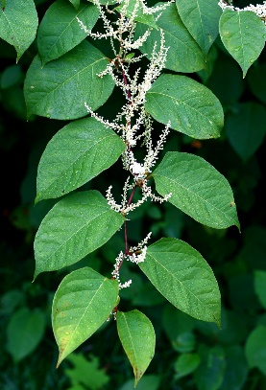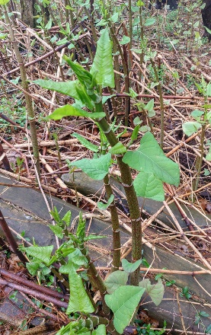
Giant hogweed  Heracleum mantegazzianum | When it's fully grown, it can reach heights of between 1.5m to 5m and have a spread of between 1 and 2m. It forms a rosette of jagged, lobed leaves in the first year before sending up a flower spike in the second year and then setting seed.  Stems are green, often with purple blotches and stiff, white, bristly hairs. Stems are hollow with ridges and have a thick circle of hairs at the base of each leaf stalk.  Leaves grow up to 1.5m wide and 3m long, deeply divided into smaller leaflets. It looks a bit like a rhubarb leaf, with irregular and very sharp or jagged, leading to it being sometimes referred to as wild rhubarb. The underside of the leaf is hairy.  Flowers appear in June and July. They are small, upward facing and white, or slightly pink, and are clustered on umbrella-like heads that can reach a diameter of 60cm.  Found throughout much of the UK, especially colonising river banks where its seeds are transported by the water. | The sap of giant hogweed can cause burns. It contains furocoumarin, which makes skin extremely sensitive to sunlight (phytophotodermatitis).  If the sap gets onto your skin and is then exposed to the sun, your skin can blister badly. Blistering can then recur over months and even years. This is known as phytotoxicity.  The best way to avoid injury is to familiarise yourself with the plant and avoid contact with your skin. Brushing through patches of giant hogweed and exposing yourself to plants that have been cut might cause you to get sap on your skin.  If you do get giant hogweed sap on your skin, be sure to wash the area thoroughly and immediately. Seek medical advice and do not expose the area to sunlight for a few days.  It is illegal to plant or deliberately allow giant hogweed to spread in the UK. If identified it should be reported to the Local Authority or Environment Agency, or follow guidance from the Environment Agency. | 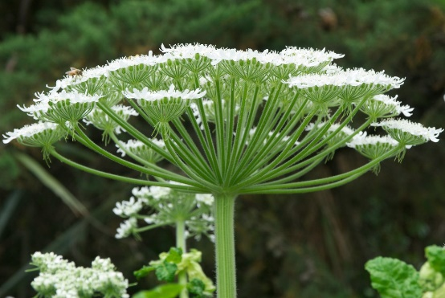  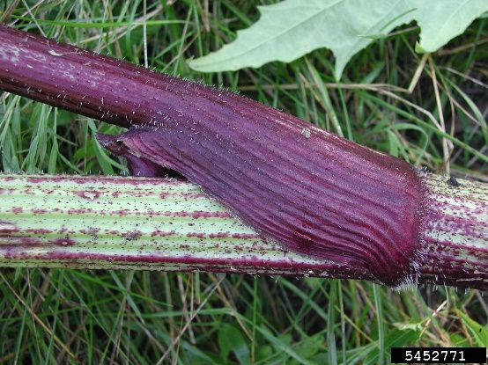  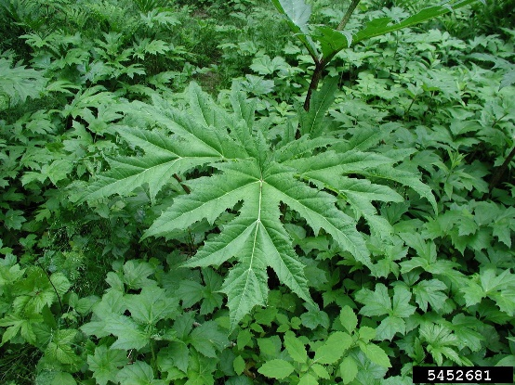

Use of Glyphosate, weedkillers, and other weed control methods
While in most cases “weed control” is not required for harmful plants, there may be some situations such as growth of invasive plants, damage to surfaces or nettles/thistles in play areas, where some form of intervention is required to prevent costly repairs or foreseeable injuries. In these cases, you can employ either chemical or manual interventions to remove plant.
Manual interventions remove the risk of accidental spraying and contamination of food-stuffs, and don’t carry the potential risk to pupils, wildlife (specifically pollinators reliant on wildflower crops and aquatic life) that may be present in the area during application or using the area afterwards. They can also be much more targeted, dealing with individual plants or varieties rather than whole areas. The Royal Horticultural Society provide extensive guidance on non-chemical control of weeds.
Chemical weed control will usually involve the application of a spray or gel to the desired area. It should always be done in line with manufacturer’s instructions, and will require the area of application to be taken out of use for a prescribed period of time. They will also usually have restrictions on the number of annual applications on any one area. Chemical applications fall in to two categories, selective and non-selective, and both will require a COSHH assessment to be completed prior to use, and records of applications should be kept.
Selective weed killers are designed to only work on specific plants, with a variety of unique formulations available to tackle specific types of weeds while avoiding grasses. They work by stimulating excessive growth in the target plant, so much so that it's no longer able to sustain its rate of growth. The plant will then die. These are effective when you want to treat weeds growing in lawns or fields.
Glyphosate is an example of a non-selective, or total, systemic herbicide / weedkiller. This means that it will kill virtually any plat to which it is applied, and if not applied carefully can kill off lawn and the plants you want to keep. It is the active substance in many herbicides (weed killers) and is widely used around the world. Non-selective weedkillers work by blocking the plant’s production of protein which it requires to survive. Non selective weedkillers are effective where hardy weeds are growing through hardstanding or brickwork.
Under the Plant Protection Products (Sustainable Use) Regulations 2012, a person who uses, or causes or permits an individual to use, a plant protection product must ensure:
all reasonable precautions are taken to protect human health and the environment
the application of the plant protection product is confined to the crop, land, produce, buildings, contents of buildings, materials or other areas intended to be treated
when the product is used in places of heightened concern (which includes, among others, areas used by the public or vulnerable groups, areas in the close vicinity of healthcare facilities, and on or along roads, railway lines, very permeable surfaces, or other infrastructure close to surface water or groundwater) that the amount used and the frequency of use are as low as reasonably practicable.

Identification tools
A number of apps and online tools are available that identify plants and fungus, and can be used to assist the school when risk assessing suspect plants on the school site. Apps should always be used with caution – you should not rely on an identification app to tell you a plant is safe, especially if it indicated the plant could be a number of different species; but it can be used to indicate additional control measures that might need to be in place for higher risk plants. Examples include:
iNatualist
Pl@ntnet

Hazardous plants list
The table in Annex 1 contains a more extensive list of plants that have been known to cause injury, either by contact or after being eaten. It mirrors the HTA (Horticultural Trades Association) guidelines.
All these plants are safe to grow provided they are treated with respect. Remember, they are ornamental plants, often very beautiful - they are not meant to be eaten. Avoid contamination by wearing gloves and covering your skin.
This is not an exhaustive list. Additional information on toxicity and irritation can be found on plants listed in our Find a Plant tool so if a specific plant you wish to check isn't listed below, do try searching there as well.
Plants are listed in categories, A to C, with A being the most toxic and C the least.

Annex 1: Plants potentially harmful to people
Category A
Toxicodendron (poison ivy) | Caution skin allergen causing severe dermatitis; poisonous if eaten
Category B
Aconitum (monkshood) | Toxic if eaten. Avoid skin contact
Allium sativum | Skin irritant/allergen
Alocasia (taro) | Toxic if eaten; skin/eye irritant
Anticlea (Zigadanus some species) | Toxic if eaten
Aristolochia (Dutchman's pipe) | Toxic if eaten
Arum (cuckoo-pint, lords-and-ladies) | Toxic if eaten; skin & eye irritant
Asarum | Toxic if eaten
Atropa (deadly nightshade) | Toxic if eaten; skin irritant
Brugmansia (angel’s trumpet) | Toxic if eaten; skin irritant; avoid eye contact
Brunfelsia (yesterday, today and tomorrow) | Harmful if eaten
Colchicum (autumn crocus) | Toxic if eaten
Convallaria majalis (lily-of-the-valley) | Toxic if eaten
Cuckoo-pint | See Arum
Curcubita | Ornamental varieties. Toxic if eaten; fruit intended for decoration only
Cycas | Harmful if eaten; skin irritant
Daphne (mezereon, spurge laurel) | Toxic if eaten; skin irritant
Datura (thornapple) | Toxic if eaten; skin irritant; avoid eye contact
Deadly nightshade | See Atropa
Dictamnus (burning bush) | Toxic to skin with sunlight
Dieffenbachia (dumb cane, leopard lily) | Toxic if eaten; skin/eye irritant
Dioscorea (syn. Tamus) | Toxic if eated; skin irritant
Digitalis (foxglove) | Toxic if eaten
Dumb cane | See Dieffenbachia
Euphorbia (spurge, poinsettia) | Irritant to skin/eye; harmful if eaten
Foxglove | See Digitalis
German primula | See Primula obconica
Ginkgo biloba | Seeds harmful if eaten
Gloriosa superba (glory lily) | Toxic if eaten
Hemlock water-dropwort | See Oenanthe
Heracleum mantegazzianum (giant hogweed) | Toxic to skin with sunlight
Heracleum sphondylium (hogweed, common hogweed) and other Heracleum spp | Toxic to skin with sunlight
Hogweed | See Heracleum
Humulus lupulus | Skin irritant/allergen
Hyoscyamus (henbane) | Toxic if eaten
Lagenaria (bottle gourd, calabash) | Toxic if eaten; fruit intended for decoration only
Lily-of-the-valley | See Convallaria majalis
Lords-and-ladies | See Arum
Lupinus (lupin) | Harmful if eaten
Mezereon | See Daphne
Monkshood | See Aconitum
Nerium oleander (oleander) | Toxic if eaten; smoke from burning is harmful
Oenanthe crocata, O. aquatica, O. phellandrium (hemlock water-dropwort, water dropwort) | Toxic if eaten
Ornithogalum (chincherinchee, star-of-Bethlehem) | Harmful if eaten
Poinsettia | See Euphorbia
Phytolacca (pokeweed) | Toxic if eaten
Pokeweed | See Phytolacca
Polygonatum (Solomon’s seal) | Harmful if eaten
Primula obconica (except primin-free cultivars) (German primula), and P. auricula | Skin irritant
Ricinus communis (castor oil plant) | Toxic if eaten
Ruta (rue) | Toxic to skin with sunlight
Solomon’s seal | See polygonatum
Spurge laurel | See Daphne
Star-of-Bethlehem - | See Ornithogalum
Tamus | See Dioscorea
Taxus (yew) | Toxic if eaten
Thornapple | See Datura
Veratrum (false hellebore) | Toxic if eaten
Water-dropwort - | See Oenanthe
Yesterday, today and tomorrow | See Brunfelsia
Yew | See taxus
Category C
Acokanthera (bushman’s poison) | Harmful if eaten
Actaea (baneberry) | Harmful if eaten
Adenium | Harmful if eaten
Aesculus (horse chestnut) | Harmful if eaten
Agapanthus (African lily) | Harmful if eaten
Agave | Skin irritant
Aglaonema (Chinese evergreen) | Harmful if eaten; skin/eye irritant
Agrostemma githago (corncockle) | Harmful if eaten
Ailanthus (tree of heaven) | Skin irritant
Allamanda | Harmful if eaten; skin/eye irritant
Aloe | Harmful if eaten
Alstroemeria (Peruvian lily) | Skin allergen
Amaryllis | See Hippeastrum
Angel’s trumpet | See Brugmansia
Angel’s wings | See Caladium
Anthriscus sylvestris (cow parsley) | Harmful to skin with sunlight
Anthurium (flamingo flower) | Harmful if eaten; skin/eye irritant
Apium graveolens (celery/celeriac) | Harmful to skin with sunlight
Arachis hypogaea | (Seed packets only) seeds from this packet are not edible
Arisaema (cobra-lily) - | Harmful if eaten; skin/eye irritant
Arisarum (mouse plant) | Harmful if eaten; skin/eye irritant
Arrowhead vine | See Syngonium
Asclepias | Harmful if eaten
Asparagus (asparagus fern) | Skin allergen; fruits harmful if eaten, poisonous
Autumn crocus | See colchicum
Azalea | See Rhododendron
Baneberry | See Actaea
Belladonna lily | See Amaryllis belladona
Bluebell | See Hyacinthoides
Brassica nigra, B. juncea (black mustard, brown mustard) | Skin irritant/allergen
Bryonia dioica (white byrony) | Harmful if eaten
Buckthorn | See Rhamnus
Bunny ears cactus | See Opuntia
Burning bush | See Dictamnus
Bushman’s poison | See Acokanthera
Caladium (angel’s wings) | Harmful if eaten; skin/eye irritant
Calico bush | See Kalmia
Calla lily | See Zantedeschia
Calla palustris (water arum) | Harmful if eaten; skin/eye irritant
Calycanthus, Carolina allspice | Harmful if eaten
Capsicum annum (ornamental pepper cultivars) | Irritant if eaten; skin/eye irritant, poisonous
Castor oil plant | See Ricinus communis
Celandine, greater | See Chelidonium majus
Chelidonium majus (greater celandine) | Harmful if eaten; skin/eye irritant
Cherry laurel | See Prunus laurocerasus
Chincherinchee | See Ornithogalum
Christmas cherry | See Solanum pseudocapsicum
Chrysanthemum | Skin allergen
Citrus (lemon, lime, bergamot orange) | Fruit harmful to skin in sunlight
Clematis (old man's beard) | Skin irritant
Cobra-lily - | See Arisaema
Colocasia esculenta (dasheen, eddo, taro) | Harmful if eaten; skin/eye irritant
Comfrey, Russian comfrey | See Symphytum
Corncockle | See Agrostemma githago
Curcubita | Edible varieties (courgette, pumpkin, squash), if crop is bitter, do not eat
Cymbidium | Skin allergen
Cypripedium (lady's slipper orchid) | Skin allergen
Cytissus | (Broom), harmful if eaten
Daffodil | See Narcissus
Dasheen | See Colocasia esculenta
Delphinium including Consolida (larkspur) | Harmful if eaten
Devil’s ivy | See Epipremnum
Dianthus (carnation, sweet William) | Skin allergen
Dracunculus (dragon arum) | Harmful if eaten; skin & eye irritant
Echium | Skin irritant
Elder | See Sambucus
Epipremnum (devil’s ivy) | Harmful if eaten; skin & eye irritant
Euonymus (spindle tree) | Somewhat poisonous
Ficus benjamina (weeping fig) | May cause skin allergen, harmful if eaten
Ficus carica (fig) | Harmful to skin with sunlight
Fig | See Ficus
Frangula (alder buckthorn) | Harmful if eaten
Fremontodendron | Skin/eye irritant
Galanthus (snowdrop) | Harmful if eaten
Gelsemium (false jasmine) | Harmful if eaten
Goosefoot vine | See Syngonium
Grevillea | Skin irritant/allergen
Hedera (ivy) | Harmful if eaten; skin irritant/allergen
Helleborus (Christmas rose, Lenten rose) | Harmful if eaten; skin irritant
Hippeastrum (amaryllis) | Harmful if eaten
Horse chestnut | See Aesculus
Hyacinthoides (bluebell) | Harmful if eaten
Hyacinthus (hyacinth) | Skin irritant
Hydrangea | Skin allergen
Ipomoea (morning glory) | Harmful if eaten
Iris | Harmful if eaten
Ivy | See Hedera
Juniperus communis (juniper) | Skin allergen
Juniperus except J. communis | Harmful if eaten, skin allergen
Kalmia (calico bush) | Harmful if eaten
Lenten rose | See Helleborus
Laburnum | Harmful if eaten
Lagenaria (bottle gourd) (syn. Cucurbita lagenaria), edible varieties | If crop is bitter, don't eat
Lantana | Harmful if eaten
Larkspur | See Delphinium
Lathyrus (except L. sativus) | Pods and seeds not edible
Laurel | See Prunus laurocerasus
Leyland cypress | See × Cupressocyparis leylandii
Ligustrum (privet) | Harmful if eaten
Lithotoma axillaris (syn. Isotoma axillaris, Laurentia axiallaris) | Skin irritant
Lobelia (except bedding lobelia, L. erinus) | Harmful if eaten, skin irritant
Lysichiton (skunk cabbage) | Harmful if eaten, skin & eye irritant
Marvel of Peru | See Mirabilis
Mentha pulegium (pennyroyal) | Harmful if eaten
Mirabilis (marvel of Peru, four o’clock plant) | Poisonous; skin irritant
Monstera deliciosa (Swiss cheese plant) | Harmful if eaten, skin & eye irritant
Morning glory | See Ipomoea
Nandina domestica (sacred bamboo) | Harmful if eaten
Narcissus (daffodil) | Harmful if eaten; skin irritant
Nicotiana (tobacco) | Harmful if eaten; avoid skin contact
Opium poppy | See Papaver somniferum
Opuntia (prickly pear, bunny ears) | Skin and eye irritant
Pagoda tree | See Sophora
Papaver somniferum (opium poppy) | Harmful if eaten
Parsnip | See Pastinaca sativa
Parthenocissus (Virginia creeper, Boston ivy) | Harmful if eaten; skin irritant
Pastinaca sativa (parsnip) | Harmful if eaten; skin irritant
Peace lily | See Spathiphyllum
Pepper, ornamental | See Capsicum annum
Peruvian lily | See Alstroemeria
Phacelia | Skin allergen
Phaseolus (navy beans, kidney beans, French bean, climbing bean, runner bean) | Raw pods/beans harmful if eaten raw
Philodendron | Harmful if eaten; skin/eye irritant/allergen
Physalis alkekengi (Chinese lantern) | Harmful if eaten, except ripe fruit
Pieris | Harmful if eaten
Pistia stratiotes (water lettuce) | Harmful if eaten; skin/eye irritant
​Plumaria (frangipani) | Harmful if eaten; skin/eye irritant
Plumbago (leadwort) | Skin irritant
Privet | See Ligustrum
Polyscias | Skin irritant
Portugal laurel | See Prunus lusitanica
Primula auricula | Skin allergen
Prunus laurocerasus, P. lustanica (cherry laurel, Portugal laurel) varieties bearing ornamental fruit | Harmful if eaten
Ranunculus (buttercup, crowfoot, celandine, spearfoot, beakwort) | Harmful if eaten; skin irritant
Rhamnus including Frangula (alder buckthorn, buckthorn) – harmful if eaten
Rheum × hybridum (rhubarb) | Harmful if eaten, except cooked leaf stalks
Rheum except R. x hybridum (Chinese rhubarb) | Harmful if eaten
Rhododendron, including Ledum, Azalea, Menziesia | Harmful if eaten
Robinia pseudoacacia (locust tree) | Harmful if eaten; skin irritant
Rumex (dock/sorrel) | Harmful if eaten in large amounts
Salvia rosmarinus (rosemary) | Skin allergen
Sambucus except S. nigra (elder) | Harmful if eaten; fruit/flowers edible if cooked
Sauromatum (voodoo lily) | Harmful if eaten; skin/eye irritant
Schefflera (Umbrella tree) | Skin irritant
Scilla | Harmful if eaten
Skunk cabbage | See Lysichiton
Sinapis alba (white mustard) | Skin irritant/allergen
Snowberry | See Symphoricarpos
Solanum tuberosum (potato) | Harmful if eaten, except potato crop
Solanum, ornamental species (including S. pseudocapsicum (syn. S. capsicastrum) and S. dulcamara) | Harmful if eaten
Sophora (pagoda tree) | Harmful if eaten
Spanish broom | See Spartium junceum
Spartium junceum (Spanish broom) | Harmful if eaten
Spathiphyllum (peace lily) | Harmful if eaten, skin & eye irritant
Spindle tree | See Euonymus
Swiss cheese plant | See Monstera deliciosa
Symphoricarpos (snowberry) | Harmful if eaten
Symphytum (comfrey, Russian comfrey) | Harmful if eaten repeatedly
Syngonium (arrowhead vine, goosefoot vine) | Harmful if eaten; skin/eye irritant
Tagetes minuta | (African marigold, French marigold), skin irritant/allergen
Taro | See Alocasia, Colocasia
Teucrium (germander) | Harmful if eaten
Thermopsis (false lupin) | Harmful if eaten
Thuja (western red cedar) | Harmful if eaten; skin allergen
Tobacco | See Nicotiana
Tradescantia | Skin allergen
Tropaeolum majus (nasturtium) | Skin allergen
Tulip | See Tulipa
Tulipa (tulip) | Harmful if eaten; skin allergen
Umbrella tree | See Schefflera
Urtica (nettle) | Skin irritant
Viscum album (mistletoe) | Harmful if eaten
Winter cherry | See Solanum pseudocapsicum
Woody nightshade | See Solanum
×Cuprocyparis leylandii (Leyland cypress) | Skin allergen
Yucca | Skin allergen
Zamia | See Zamioculcas
Zamioculcas | Harmful if eaten, skin/eye allergen/irritant
Zantedeschia (calla lily) | Harmful if eaten; skin & eye irritant

