Schools new and expectant mothers at work guidance
Contents
Introduction 2
Notification 2
Risk assessment 2
What types of hazards and risks should we be looking for? 3
Physical Hazards: 3
Biological Agents: 3
Chemical Hazards: 3
Working Conditions: 3
Aspects of pregnancy that may affect work 4
Can new or expectant mothers still work at night? 4
What facilities we must provide? 5

Introduction
Workplace risk assessment should already consider any risks to female employees of childbearing age and, in particular, risks to new and expectant mothers (for example, from working conditions, or the use of physical, chemical or biological agents). Any risks identified must be included and managed as part of the general workplace risk assessment.
New and Expectant Mothers can be defined as ‘a woman who is pregnant, who has given birth within the previous 6 months or women who are breast feeding’.
Being pregnant, or a new mother, does not prevent a woman from working and developing her career. Many women work while they are pregnant and return to work while they are breastfeeding.

In many workplaces, there are risks, which may affect the health and safety of new and expectant mothers and that of their child. Working conditions generally considered acceptable may no longer be so during pregnancy and while breastfeeding, so action will be required.

Notification
Whilst there is no legal requirement for employees to inform us that they are pregnant or a new mother, they should bear in mind that (Employer & School Name) are not required to take any specific action until written notification is provided. It is therefore important for the employee and her child's health and safety that employees provide written notification as early as possible. (Employer & School Name) can also ask for a certificate from the employee's GP or midwife stating that the employee is pregnant.
Employers must take two actions:
- Initial workplace risk assessment. (Risk Assessment of the role or task applicable to all those effected)
- Risk assessment on notification of pregnancy, birth or breastfeeding. (Risk assessment specific to the individual who has notified)

Risk assessment
Managers should already have drafted a hazard identification list for their workplaces in accordance with the Hazard identification and risk management procedure. After identifying those hazards Managers should have ensured that, a competent person has drafted and communicated to relevant employees a suitable and sufficient risk assessment that details any required control measures.
All the below actions should be monitored and reviewed on a regular basis or at the commencement of every trimester of the pregnancy.
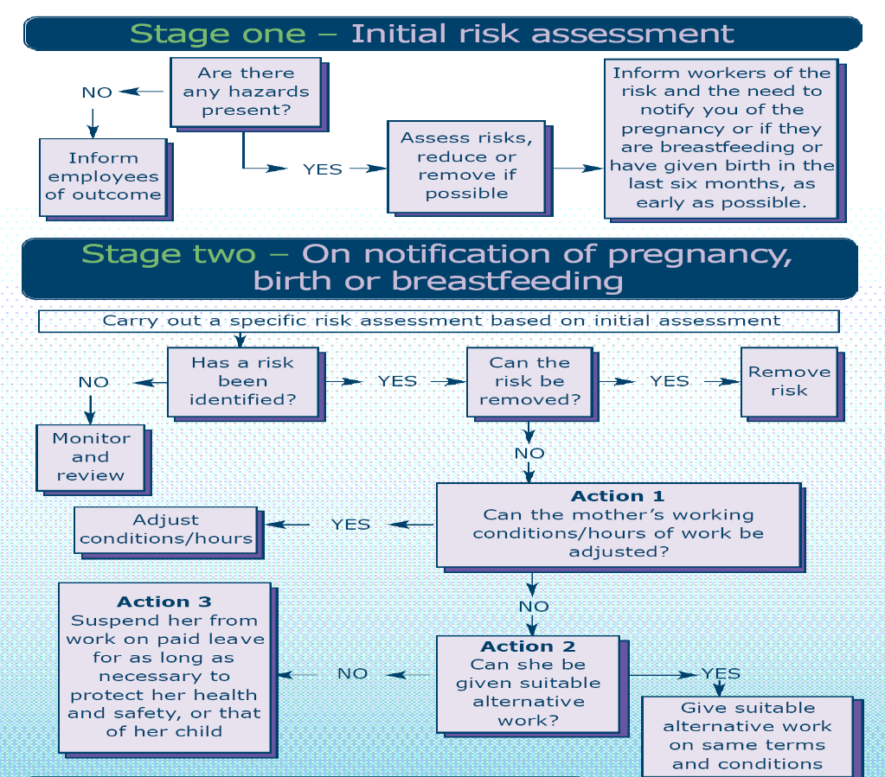

What types of hazards and risks should we be looking for?
The following checklist is a useful tool to help identify risks that could be harmful to the health and safety of new and expectant mothers and their children.

Physical Hazards:
- Awkward spaces and workstations
- Vibration
- Noise
- Radiation (covered by specific legislation)

Biological Agents:
- Infections
- Communicable diseases

Chemical Hazards:
- E.g. chemical handling (handling drugs or specific chemicals such as pesticides, lead etc.)

Working Conditions:
- Inadequate facilities (including rest rooms)
- Excessive working hours (night work etc.)
- Unusually stressful work
- Exposure to cigarette smoke
- High or low temperatures
- Lone working
- Work at heights
- Traveling
- Exposure to violence
- Physical interventions

Aspects of pregnancy that may affect work
The following list provides some aspects of pregnancy that may affect a woman’s ability to undertake some or all of her job.
Morning sickness | Early starts. Exposure to nauseating smells, which could include cooking, chemicals, cleaning products.
Backache | Standing for long periods. Manual handling. Posture
Fainting | Working in hot conditions. Getting up from seated position too quickly.
Hemorrhoids | Working in hot conditions
Varicose veins | Standing or sitting for long periods.
Frequent visits to the toilet | Difficulty leaving job or site of work.
Increasing size | Use of protective clothing. Working in confined areas. Manual handling.
Tiredness | Overtime. Evening work.
Comfort | Problems of working in tightly fitting work uniforms.
Balance | Problems of working on slippery, wet surfaces. Working at height.
Dexterity, agility and co-ordination, speed of movement and reach may be impaired because of increasing size | Physical jobs and tasks.

Can new or expectant mothers still work at night?
Yes. Unless there is a specific work risk and GP/Midwife has provided a medical certificate stating that new or expectant mother must not work nights. If this is the case then Line Manager must offer suitable alternative day work on the same terms and conditions and if that is not possible, then suspend new or expectant mother from work on paid leave for as long as necessary to protect her and/or child health and safety.

What facilities we must provide?
The Workplace Regulations require employers to provide suitable facilities for pregnant and breastfeeding mothers to rest. Where necessary these should include somewhere for the woman to lie down.

It is good practice, for employers, to provide a private, healthy and safe environment for nursing mothers to express and store milk (but this is not a legal requirement). It is not suitable to use toilets for this purpose.

